WorkShop 4 - Rock, Paper, Scissors

Group 4:

## Vikor Makarov

## Luca Novello

# 

Pseudocode

1. Start.
2. Set a timer for 3 sec
3. Create a variable called “computerObject”.
4. Run a function that can output a random number between 1-3.
5. Is the random number = 1?
   1. Yes: Set computerObject to “Scissors”; continue (step: 7).
   2. No: continue (step: 6).
6. Is the random number = 2?
   1. Yes: Set computerObject to “Rock”; continue (step: 7).
   2. No: Set computerObject to “Paper”: continue (step: 7).
7. Render animated countdown screen
8. Ask the player to select an option.
9. Did the player select an option?
   1. Yes: store player option: continue (step: 11)
   2. No: continue (step: 10)
10. Does timer = 0 sec?
    1. Yes: store random option for player: continue (step: 11)
    2. No: Update timer; continue (step: 7)
11. Is the game a tie?
    1. Yes: continue (step: 2)
    2. No: continue (step: 13)
12. Does the player have “rock” and the computer has “paper”?
    1. Yes: Computer is winner(step: 15)
    2. No: continue (step: 13)
13. Does the player have “paper” and the computer has “scissors”?
    1. Yes: Computer is winner(step: 15)
    2. No: continue (step: 14)
14. Does the player have “scissors” and the computer has “rock”?
    1. Yes: Computer is winner(step: 15)
    2. No: Player must be winner: (step: 15)
15. Render Winner screen
16. End

# Logic 3 - Pseudocode:

1. Start.
2. Set a timer for 3 sec
3. Create a variable called “computerObject”.
4. Run a function that can output a random number between 1-3.
5. Is the random number = 1?
   1. Yes: Set computerObject to “Scissors”; continue (step: 7).
   2. No: continue (step: 6).
6. Is the random number = 2?
   1. Yes: Set computerObject to “Rock”; continue (step: 7).
   2. No: Set computerObject to “Paper”: continue (step: 7).
7. Render animated countdown screen
8. Does timer = 0 sec?
   1. Yes: continue (step: 10)
   2. No: Update timer; continue (step: 8)
9. End: (Continue to Next Logic)

Flowcharts:

# Overall Flowchart:

# 

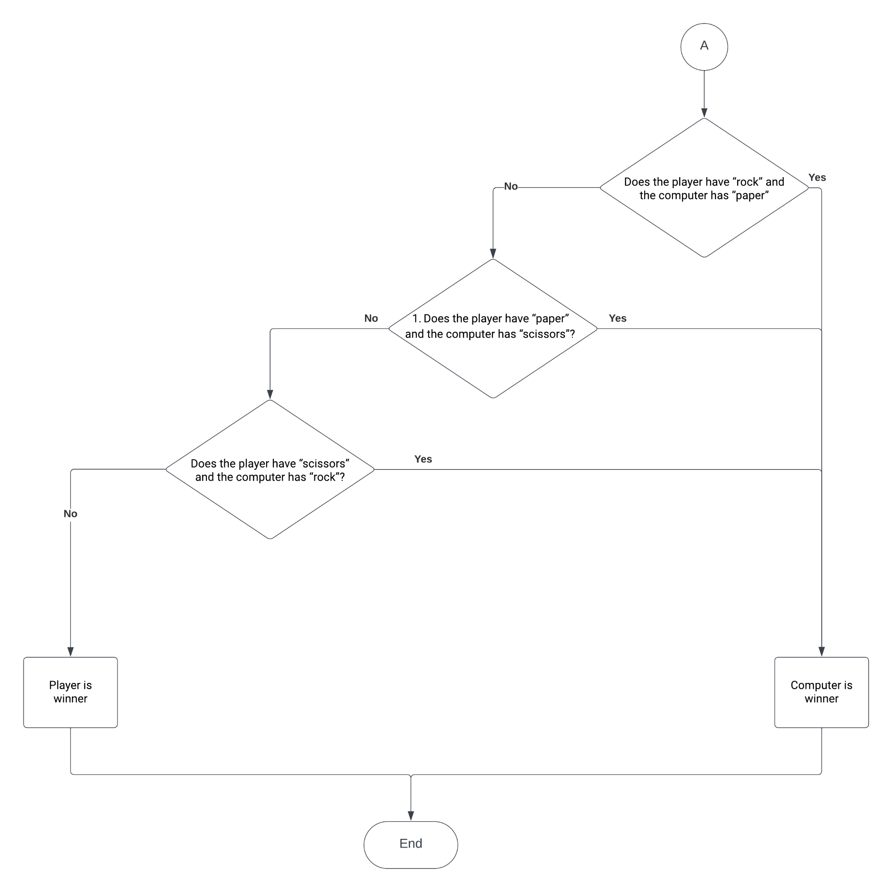

Test Logic

# Conditions:

* Timer is 3 sec
* Delta is 1 sec
* Player chose the rock
* Random number function is 2

# 

# Test: (Follow the Flowchart)

Start:

1. Set timer 3 seconds
2. Random number is 2
3. Set Computer to “Paper”
4. Ask the player to select an option: Yes
5. Player selected the “Rock”
6. Compare player and computer options
7. Computer is winner

End

Final Description

There are three main points in our program. First is the timer which is set to 3 seconds, and it decreases each iteration by delta time. Second is the block of random. The main idea is to get a random number from [1-3], where 1 - scissors, 2 - rock, 3 - paper. The last idea is to check if the game has tied (Player and Computer have the same options) before other assessments. It cuts the amount of steps because we have or 9, but there are 3 tie games, so we skip those steps and make the program shorter.